* Top features to consider for subsequent modeling are Runs, total_chairs, vertical_drop, and last year and projected days open, as they are shown to have postive correlations to higher ticket prices. Negatively correlated features like total_charis_runs_ratio and total_chairs_skiable_ratio are counterintutitive and appears to suggest an exclusiveity vs. mass market effect; this hypothesis requires the number of vistiors per year to validate.
* The price predicting model suggests the potential for raising the price above $83 (potentially much higher), but this would mean making additional enhancements to the facility to support the price increase. The resort is already positioned in the premium segment of the market and is priced competitively compared to other resorts offering similar amenities. Since Big Mountain has an geographical advantage to compete in the premium market, upgrading the facility to charge a higher price while attracting more visitors would increase the resort's competitive advantage in a pro market cycle.

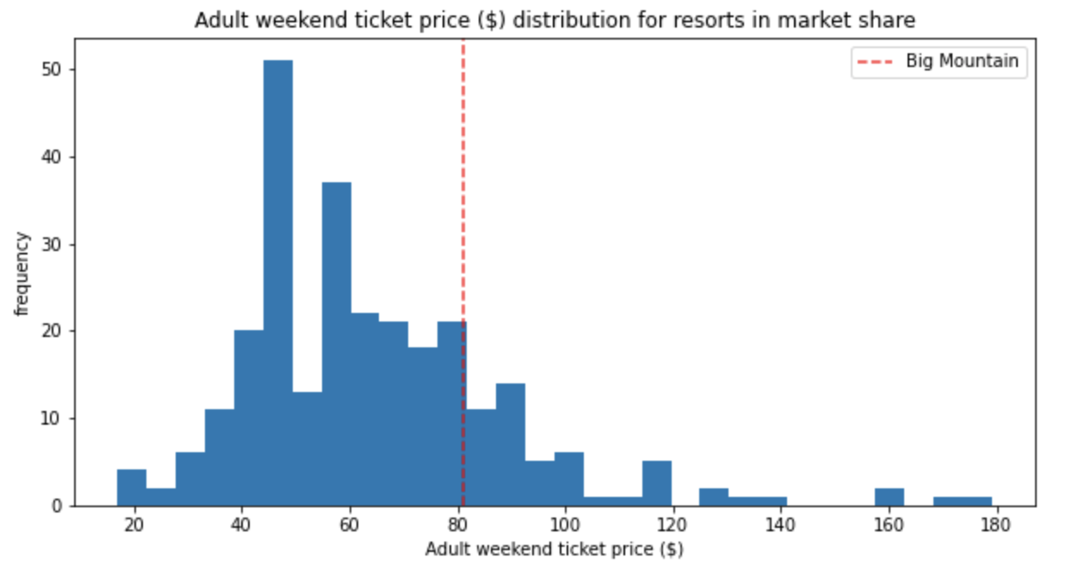

* Of the 4 scenarios presented, the data science team believes that Big Mountain should
* **Close the least used run**

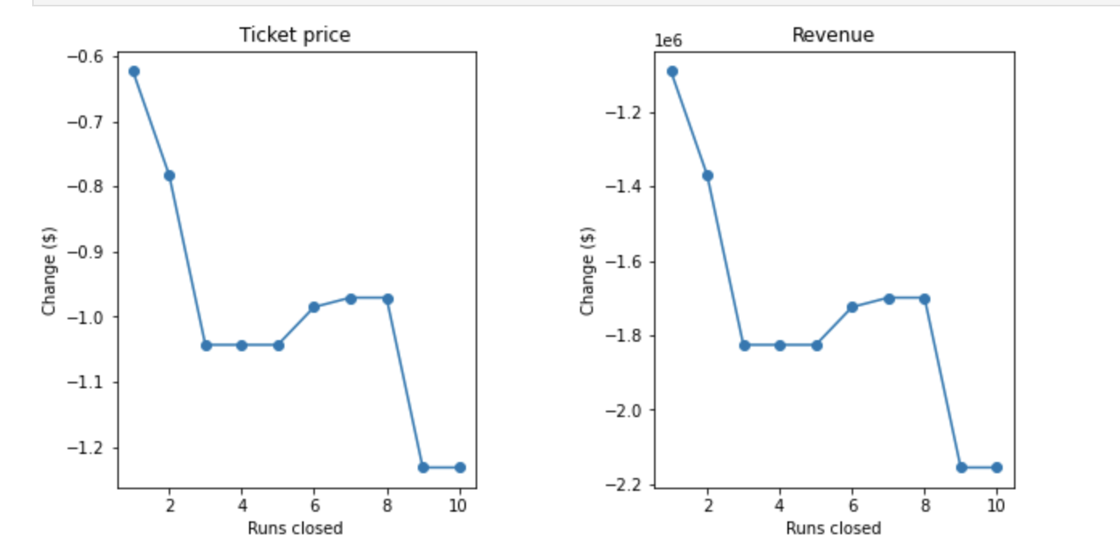

* **Enact Scenario 2**, which is increase the vertical drop by adding a run to a point 150 feet lower down but requiring the installation of an additional chair lift to bring skiers back up, without additional snow making coverage

|  |  |  |
| --- | --- | --- |
| Scenario | Ticket Price Delta | Revenue Delta |
| 2 | * $1.74 | * $3043478 |
| 3 | * $1.74 | * $3043478 |
| 4 | * $0 | * $0 |

* Additional consideration to improve the model, as the next step, is to source and incorporate (1) operating cost data into the consider and (2) visitor volume across the U.S. Surveying the market for willingness to pay a premium by amenities and features should be considered as well.
* Other consideration, invite a cross-functional team of business experts to try the model and test the business assumptions. To make the model assessable, the model could package in an API that can either called directly from a spreadsheet or is embedded and deployed through an interactive dashboard accessible via the intranet.